

Task 4 – Credit Submission

Student Name: Truong Ngoc Gia Hieu
Student Number (Vietnam/Australia): SWS01217/105565520

Task Credit4a
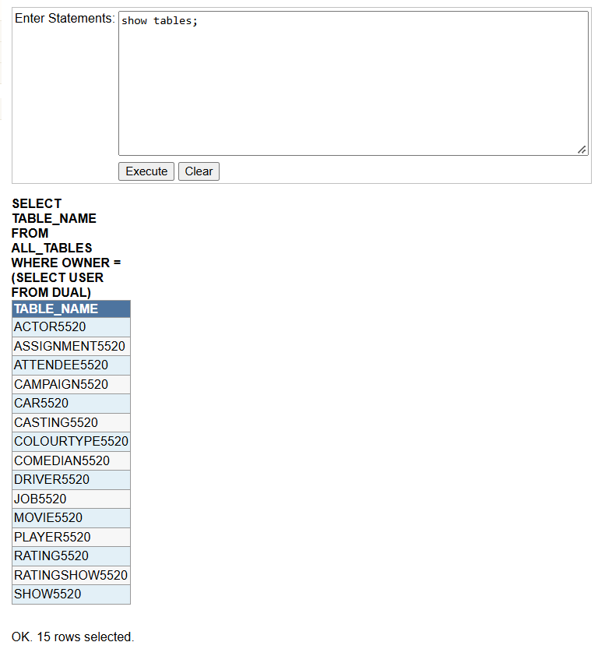
According to the description, the task requires students to list the following columns named StudentID, MovieNo, movie title, colour name, and short rating description of every movie. In addition, the list must be sorted in descending order of movie title. First of all, I need to check that all tables have been successfully created and verified in the database by using the command 'show tables;'. Then, I write the SQL statement and execute the query for task Credit4a.
Figure 1: Verification of All Created Database Tables in iSQL JunioR.
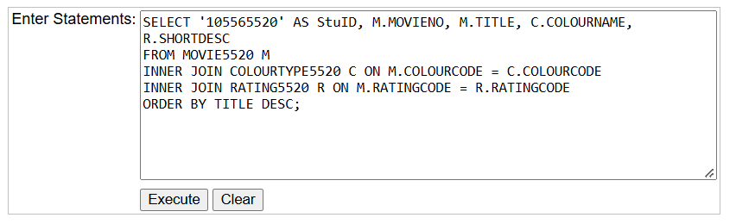
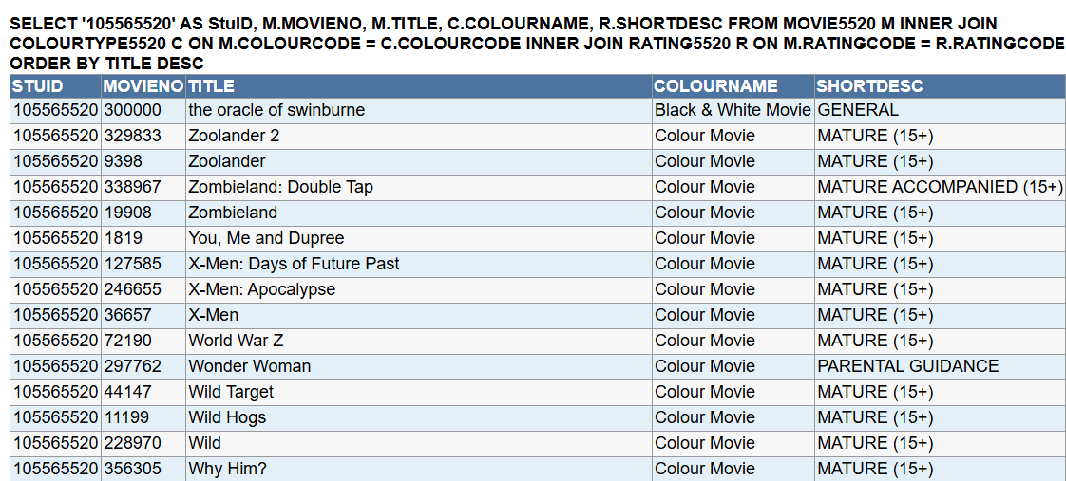
Figure 2: SQL Query Statement for Task Credit4a.
Figure 3: Output Result for Task Credit4a SQL Query.

Task Credit4b
In the next sub-task, students are required to write an SQL statement to list the stuid, actor fullname, movie title, and release year for each casting row in the Casting table. Notably, the list must be in descending order of actor fullname.
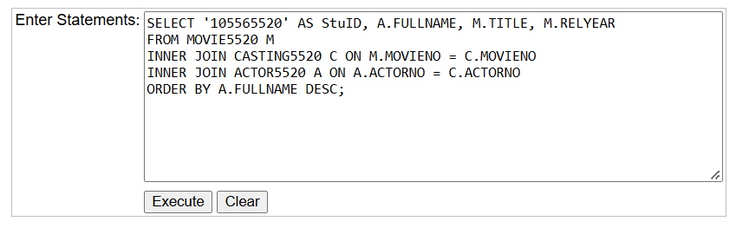
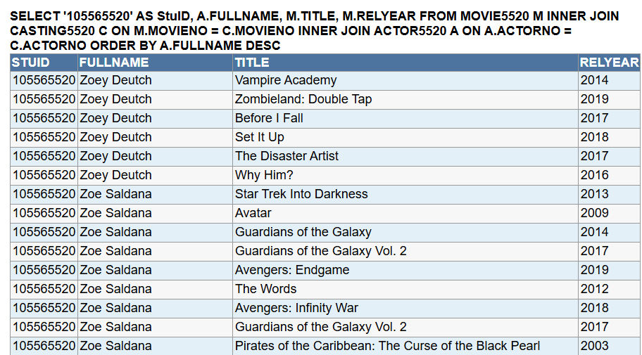
Figure 4: SQL Query Statement for Task Credit4b.
Figure 5: Output Result for Task Credit4b SQL Query.

Task Credit4c
In the third task, students have to write an SQL statement to list the stuid, rating code, and the count of movies that belong to that rating code based on the movie table. In addition, the list should be in descending order of count.
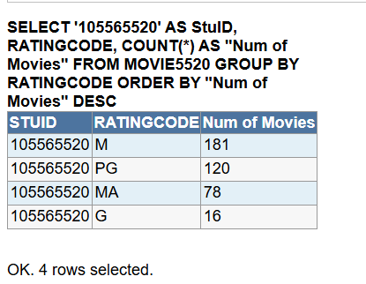
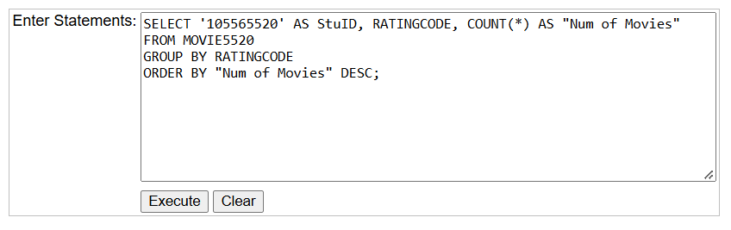
Figure 6: SQL Query Statement for Task Credit4c.
Figure 7: Output Result for Task Credit4c SQL Query.

Task Credit4d
Similar to task Credit4c, the description adds a new requirement to only include results where the count is greater than 21.
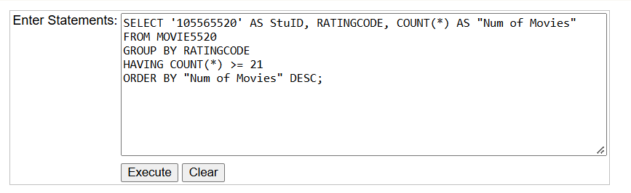
Figure 8: SQL Query Statement for Task Credit4d.
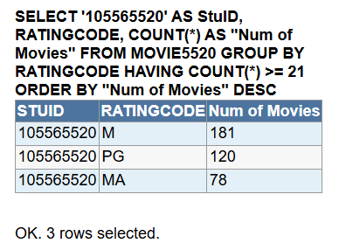
Figure 9: Output Result for Task Credit4d SQL Query.

Task Credit4e
Next, for task Credit4e, students are required to write an SQL statement that counts the movies by rating code, with an additional filter restricting the records to movies released between 1996 and 2010 (inclusive).
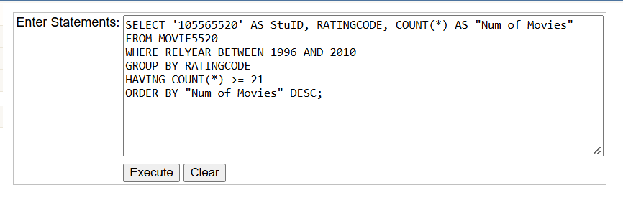
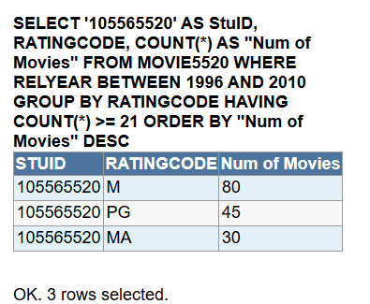
Figure 10: SQL Query Statement for Task Credit4e.
|
Figure 11: Output Result for Task Credit4e SQL Query.

Task Credit4f
In task Credit4f, students are required to write an SQL statement to list the stuid, actor fullname, gender, and the total number of movies they have appeared in, with the column heading renamed to 'Total Movies'. In addition, the resulting list must be sorted in descending order of actor fullname.
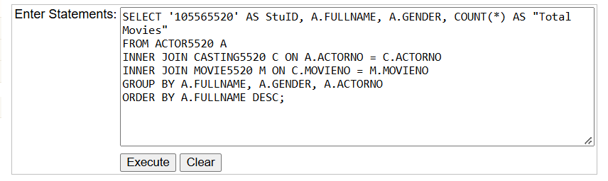
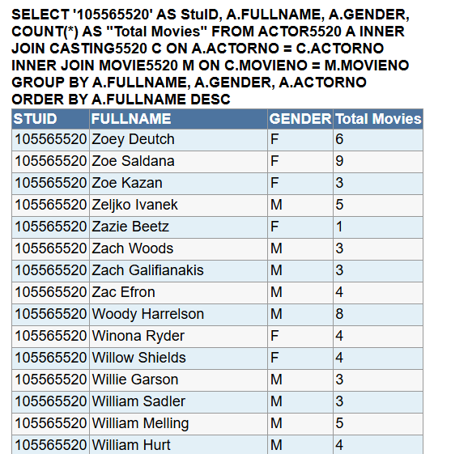
Figure 12: SQL Query Statement for Task Credit4f.
Figure 13: Output Result for Task Credit4f SQL Query.

Task Credit4g
In task Credit4g, students are required to write an SQL statement to list the stuid, actor fullname, rating code, and the number of movies they appeared in for that code. Furthermore, the resulting list must be sorted in ascending order by actor fullname and rating code.
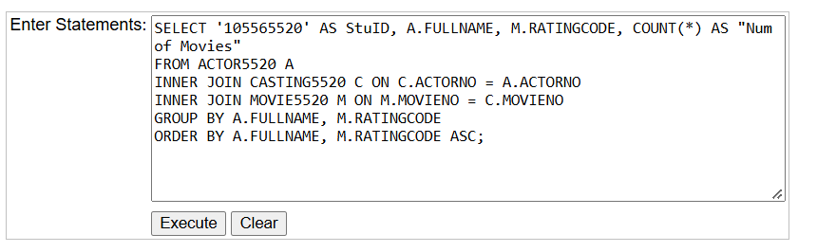
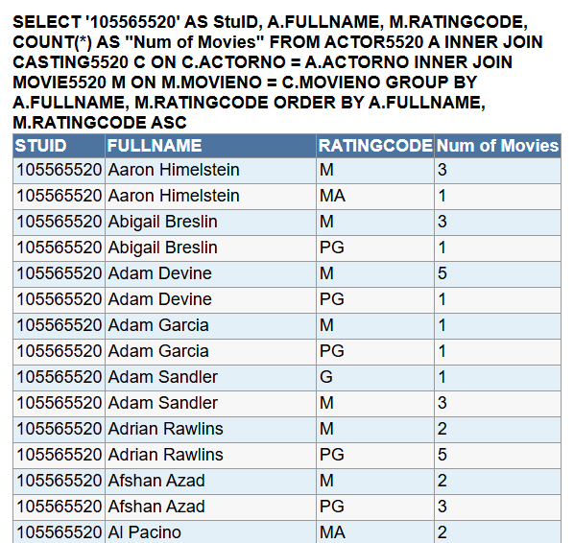
Figure 14: SQL Query Statement for Task Credit4g.
Figure 15: Output Result for Task Credit4g SQL Query.

Task Credit4h
In task Credit4h, students are required to download the SQL script named task04_customers.txt and modify it by replacing all occurrences of customerXXXX with customer5520 (utilizing the last 4 digits of my student ID). Subsequently, an SQL statement must be constructed to calculate the sum of all sales this year grouped by state and gender, including only customers with a rating code of 1, 2, or 3. Furthermore, the resulting list must be sorted in ascending order by state and gender sequence.
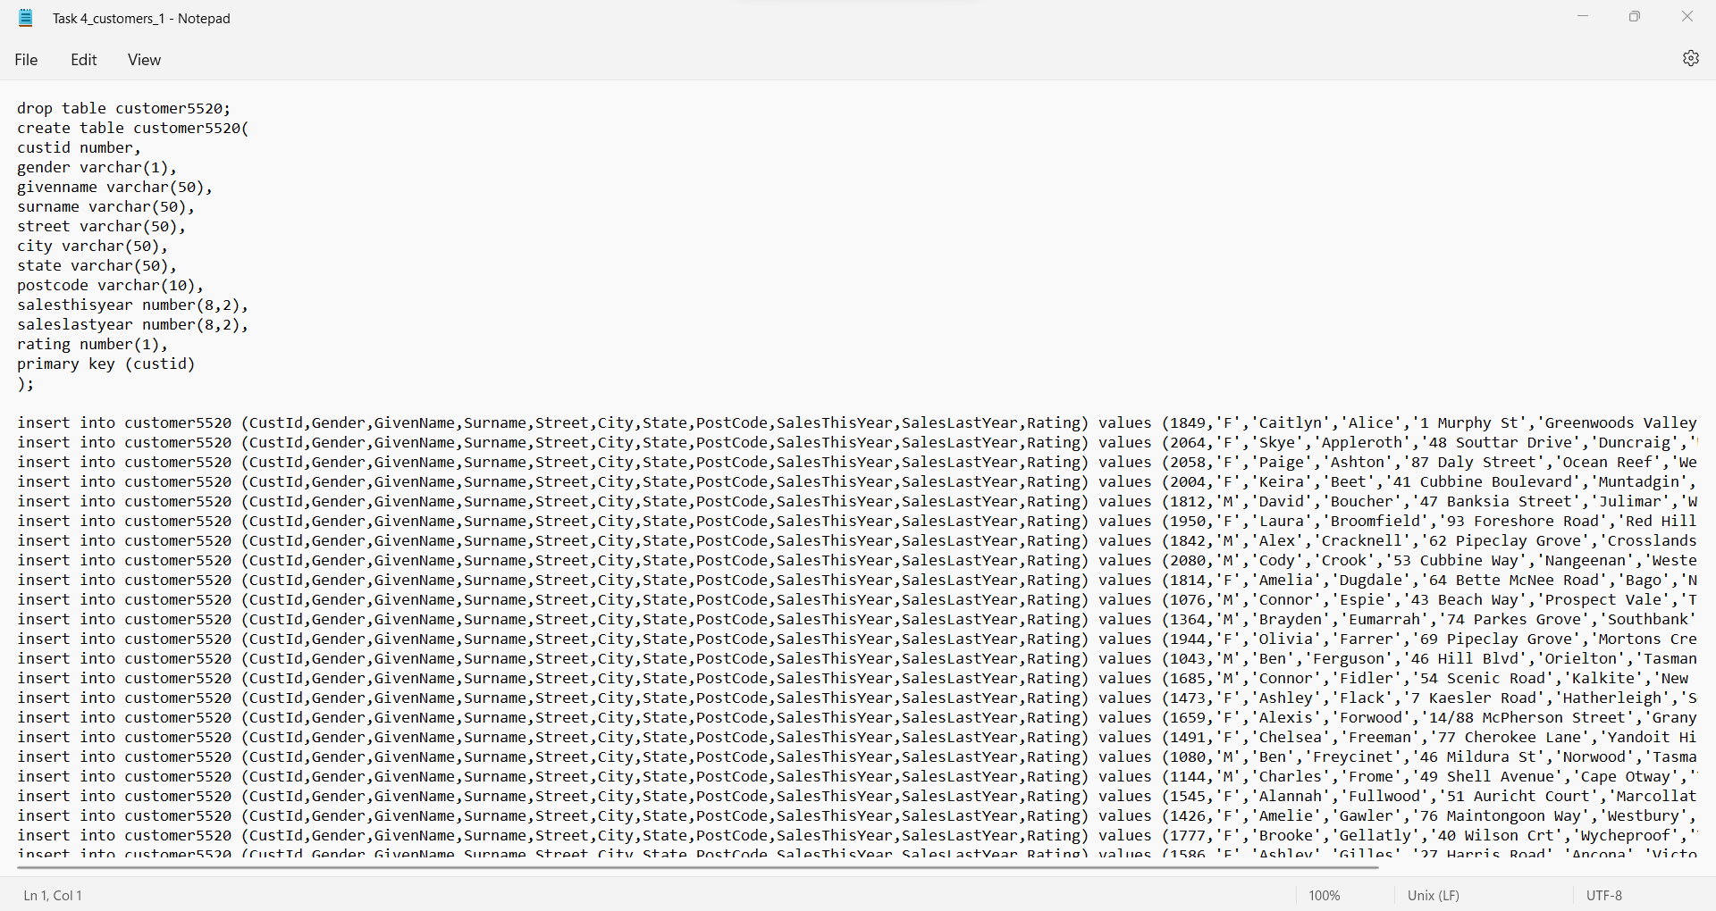
Figure 16: Table Creation and Data Insertion Script for customer5520.
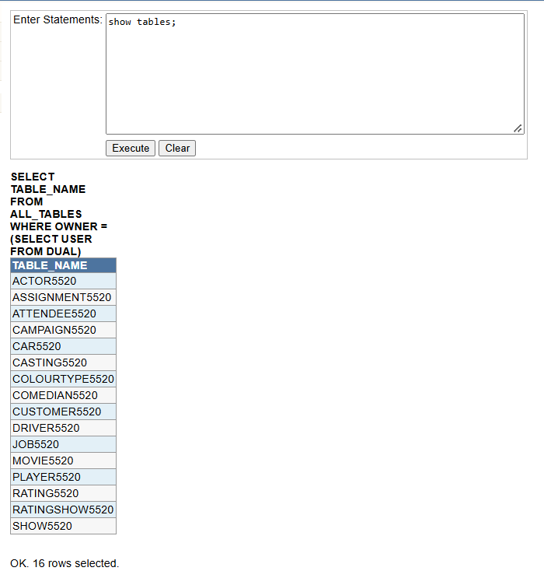
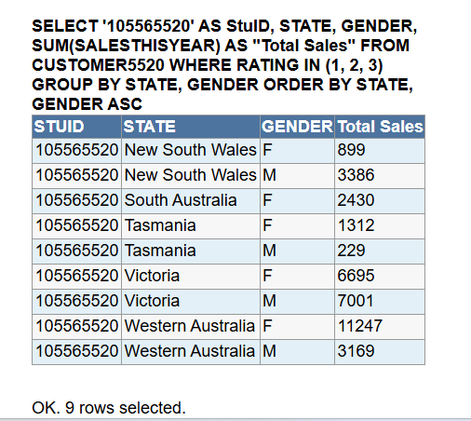
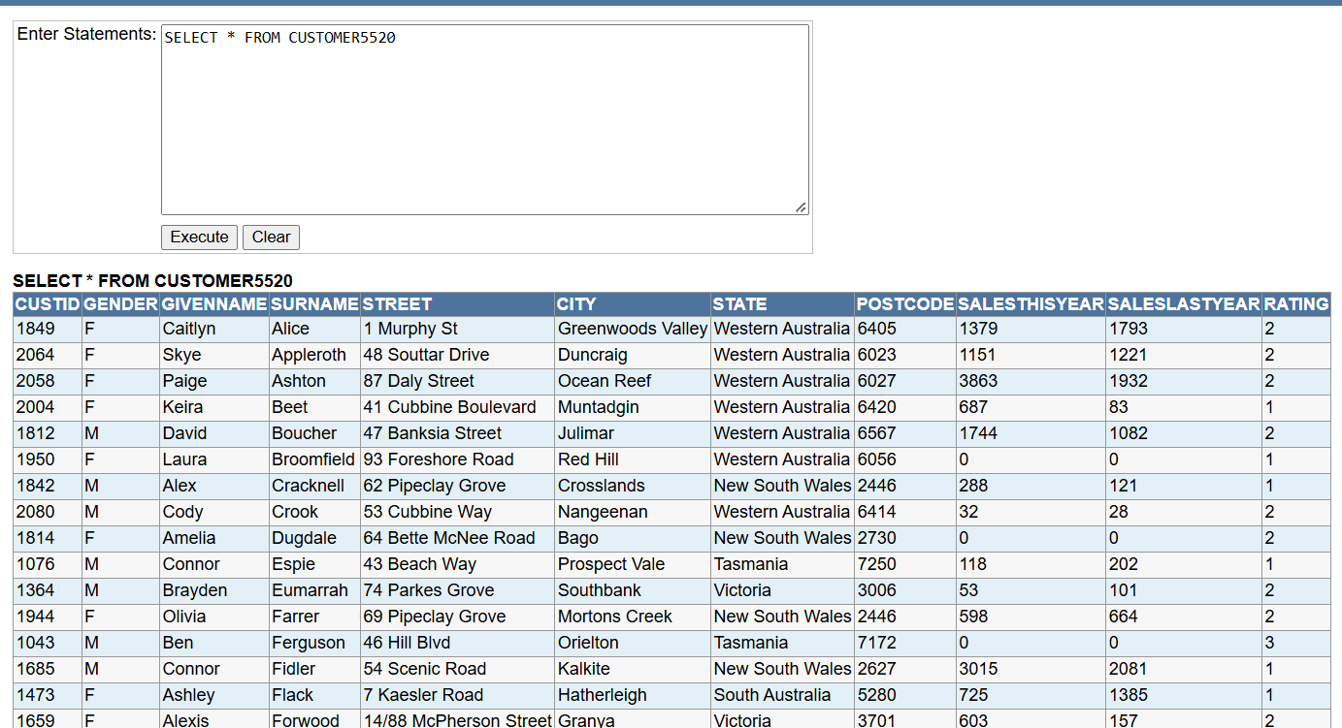
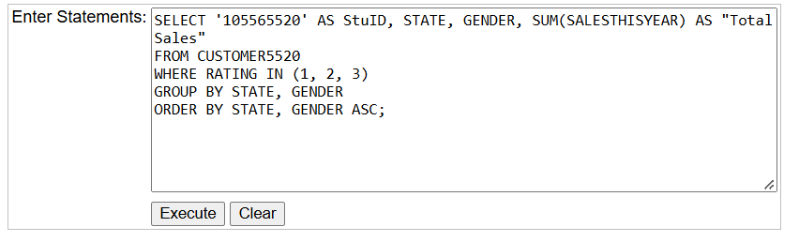
Figure 17: List of Database Tables Verified in iSQL JunioR.
Figure 18: Data Verification for Table CUSTOMER5520.
Figure 19: SQL Query Statement for Task Credit 4h.
Figure 20: Output Result for Task Credit4h SQL Query.
Conclusion
In conclusion, this assignment successfully applied core Oracle SQL concepts within the iSQL JunioR environment, including:
It is clear from the Figure 20 that the query results show the total sales this year (SALESTHISYEAR) grouped by state and gender for customers with a rating code of 1, 2, or 3. Overall, the data indicates variations in purchasing performance across different regions, with certain states exhibiting significantly higher total sales than others. Additionally, the breakdown by gender reveals distinct spending distributions within each state, providing valuable insights into customer purchasing behaviors based on their demographics and ratings.
- Table management and schema constraints standardized with the 5520 suffix.
- Advanced querying utilizing INNER JOIN operations, aggregate functions (COUNT, SUM), and filtering conditions (WHERE, IN).
- Data grouping and sorting (GROUP BY, ORDER BY) to extract accurate analytical reports regarding actors, movies, and customer sales by region.
Overall, the project effectively reinforced practical relational database management and querying skills.

